

SCHOOL OF MECHANICAL & MANUFACTURING ENGINERRING

NUST

Department of Mechanical Engineering

CS-114 – Fundamentals of Programming

Assignment #01

**Course Instructor**: Dr Khawaja Fahd Iqbal

**Lab Instructor**: Muhammad Affan

**Student Name**: Muhammad Usman Abdullah

**Section**: B

**CMS ID**: 461513

**DATE**: 22-November-2023

TASK 1:

Write a C++ program to display factors of a number using for loops.

Program:

#include <iostream>

using namespace std;

int main(){

int num;

cout<<"Enter a number: "<<endl;

cin>>num;

cout<<"The factors of the number "<<num<<" are: "<<endl;

for(int i=1;i<=num;++i){

if(num%i==0){

cout<<i<<endl;

}

}

return 0;

}

OUTPUT:

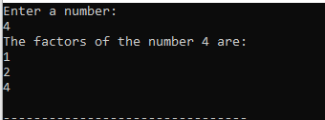

TASK 2:

Write output to the following code.

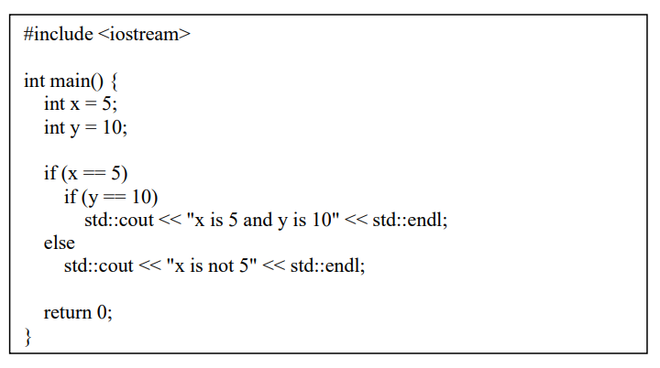

OUTPUT:

X is 5 and Y is 10

TASK 3:

Write a C++ program, take an integer value from user and check if it’s greater than 10 and less than equal to 20. Print 1 if yes and print 0 if no. Use appropriate datatype for output.

Program:

#include <iostream>

using namespace std;

int main(){

int n;

cout<<"Enter an integer value: ";

cin>>n;

if(n>10 && n<=20){

cout<<"1"<<endl;

}

else{

cout<<"0"<<endl;

}

return 0;

}

OUTPUT:



TASK 4:

Write a C++ program that uses a while loop to find the largest prime number less than a given positive integer N. Your program should take the value of N as input from the user and then find the largest prime number less than or equal to N. You are not allowed to use any library or pre-existing functions to check for prime numbers.

Program:

#include <iostream>

using namespace std;

int main(){

int N;

cout<<"Enter a positive integer: ";

cin>>N;

while(N>=2){

int f=0;

int a=1;

while(a<=N){

if(N%a==0){

f++;

}

a++;

}

if(f==2){

cout<<"The Largest Prime Number is: "<<N;

break;

}

N--;

}

return 0;

}

OUTPUT:



TASK 5:

Write a C++ program, take two string as input from user and check if both strings are equal or not. If they are equal make them unequal by rotating string. e.g., Hello is turned into olleH etc.

Program:

#include <iostream>

using namespace std;

int main()

{

string str1,str2,r;

cout<<"Enter the first string:";

cin>>str1;

cout<<"Enter the second string:";

cin>>str2;

if (str1 == str2){

for (int x=0;x<str1.length();x++){

r=str1[x]+r;

}

cout<<"Strings are unequal. Rotated string is : ";

cout<<r;

}

else {

cout<<"Strings are unequal";

}

return 0;

}

OUTPUT:



TASK 6:

Perform division in C++ without / using for loops. You can use / only to display the final results. Your dividend must be greater than divisor.

Program:

#include <iostream>

using namespace std;

int main() {

int divid, div, q=0;

cout<< "Enter dividend: ";

cin>>divid;

cout<<"Enter divisor: ";

cin>>div;

int x=divid;

if(div == 0) {

cout << "Error: Division by zero." <<endl;

}

while (x >= div) {

x -= div;

q++;

}

cout<<divid<<" / "<<div<<" = "<<q<<endl;

return 0;

}

OUTPUT:

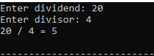

TASK 7:

Write a C++program for a string which may contain lowercase and uppercase characters. The task is to remove all duplicate characters from the string and find the resultant string.

Program:

#include <iostream>

using namespace std;

#include <string>

int main(){

string str,final;

cout<<"Enter a string: ";

cin>>str;

bool ch;

for(int i=0;i<str.length();++i){

ch=false;

for(int j=0;j<final.length();++j){

if(str[i] == final[j]){

ch=true;

}

}

if(ch==false){

final+=str[i];

}

}

cout<<"The Resultant String is"<<endl;

cout<<final;

return 0;

}

OUTPUT:



TASK 8:

Suppose an integer array a[5] = {1,2,3,4,5}. Add more elements to it and display them in C++.

Program:

#include <iostream>

using namespace std;

int main(){

int a[5]={1,2,3,4,5};

int n=8;

int b[8];

for(int i=0;i<5;++i){

b[i]=a[i];

}

int n1,n2,n3;

cout<<"Enter the first element to add to the array: ";

cin>>n1;

cout<<"Enter the second element to add to the array: ";

cin>>n2;

cout<<"Enter the third element to add to the array: ";

cin>>n3;

b[5]=n1;

b[6]=n2;

b[7]=n3;

cout<<"The New Array is: ";

for(int i=0;i<8;++i){

cout<<b[i]<<" ";

}

return 0;

}

OUTPUT:

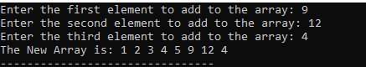

TASK 9:

Given an integer array and an integer X. Find if there’s a triplet in the array which sums up to the given integer X.

Program:

#include <iostream>

using namespace std;

int main()

{

int array[5], X, final;

bool triplet = false;

cout<<"Enter the value of X: ";

cin>>X;

cout<<"Enter the integers for array: "<<endl;

for (int i = 0; i<5; i++) {

cin>>array[i];

}

cout<<"Triplets that sum up to "<<X<<" is: "<<endl;

for (int i = 0; i<5; i++) {

for (int j = 0; j<5; j++) {

if (i == j)

continue;

for (int k = 0; k<5; k++) {

if (k == i || k == j)

continue;

final = array[i] + array[j] + array[k];

if (final == X) {

cout<<array[i]<<" "<<array[j]<<" "<<array[k]<<endl;

triplet = true; }

}

}}

if (triplet == false) {

cout<<"No Triplet";

}

return 0;

}

OUTPUT:

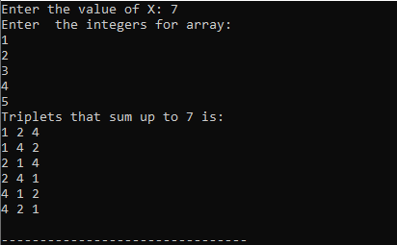

TASK 10:

Implement Bubble Sort on an array of 6 integers.

Program:

#include <iostream>

using namespace std;

int main(){

int a[6];

cout<<"Enter the elements of the array: "<<endl;

for(int i=0;i<6;++i){

cin>>a[i];

}

for(int i=0;i<5;++i){

for(int j=0;j<5;++j){

if(a[j] > a[j+1]){

swap(a[j],a[j+1]);

}

}

}

cout<<"The Sorted Array is: "<<endl;

for(int i=0;i<6;++i){

cout<<a[i]<<" ";

}

return 0;

}

OUTPUT:

